No Correlation Found between Body Mass and Diversification Rate across 1931 Species of Birds

Logan C. Bower

BIOL 461 – Principles of Evolution
Jonathan S. Mitchell, Ph.D.
28 Apr 2022
Introduction
In scientific literature, speciation rate has traditionally been defined as the rate at which species form new species. Extinction rate is traditionally defined as the opposite: the rate at which species cease to exist. The combining of these two rates yields diversification rate (DR). DR is an important metric in constructing evolutionary history of different clades of organisms and is a crucial factor in the content of this paper.
Throughout the history of the study of evolutionary biology, it has been widely accepted that differing DRs across clades have been a result of extrinsic factors, including geological and climatic factors (Gillespie and Roderick 2014). While this conclusion is supported by a substantial amount of evidence, it does not explain why certain clades that live in the same areas exhibit differing DRs, suggesting that some other factor(s) could be at play. One widely accepted explanation of this issue is intrinsic, naturally occurring features within species influence DR in conjunction with extrinsic factors (Diaz et al. 2019). However, this explanation is somewhat vague, as by definition, intrinsic features are any naturally occurring trait a species might possess. Because of this, research must be done to determine which, if any, intrinsic features in species might influence DR. The results of one study published recently suggested a link between larger brain size and higher DR rates in birds around the world (Sayol et al. 2019). These findings are a definite step in the right direction, and a great contribution to work towards a better understanding of the factors that influence DR. However, brain size might not be the only intrinsic factor that influences DR in these birds.
To follow up and build upon previous findings of a positive correlation between larger brain size and DR in birds (Sayol et al. 2019), this analysis will explore if overall body mass and DR are also correlated. The concept of body mass and DR being linked is especially intriguing due to previous studies being done that concluded DR rates were highly correlated with the evolution rate of body size in currently living species of ray-finned fish (Rabosky et al. 2013). While body size was used as the intrinsic trait in this study in place of body mass, it would be a reasonable assumption for these two traits to naturally have a correlation. Based on those previous findings, one could reasonably hypothesize that body mass and DR in birds will be positively correlated.

Methods
Data Collection
The data used in this analysis, retrieved using the Dryad Digital Repository, was the same data used by Sayol et al. in their 2019 analysis which linked brain size to higher DRs in birds (Sayol et al. 2019). It included a dataset of several traits for each of the 1931 different species of birds which were used in this analysis. The traits themselves were compiled by Sayol et al. from several different published sources and estimated in the rare cases where no data could be found in previously published literature. The DR trait and body mass (grams) traits used in this analysis were parsed from this dataset. It should be noted that the DRs used for each bird species in this analysis were calculated using the methods of Sayol et al. The definition of DR for the purposes of this analysis is an inversion of the equal splits (ES) metric of evolutionary isolation (Redding and Mooers 2006). The ES measure for a species is essentially the sum of all the edge lengths on a tree from that species to the root, with each consecutive edge being discounted by a factor of 0.5. One can think of it as the phylogenetic distinctiveness of a species in comparison to other species. Once inverted, it can be interpreted as the rate at which a species splits off from other species (Sayol et al. 2019). Because of its similarity to estimates of speciation rate (Title and Rabosky 2018), DR can be compared to models of speciation produced from BAMM models.
With DR properly defined, the methods of its acquisition can now be explained. These methods first involved using the function “evol.distinct” from the R package picante (Kembel et al. 2010). Using this function, Sayol et al. created a set of 100 trees, each using the largest phylogeny of birds available, which contains 9993 species (Jetz et al. 2012). From there, the median DRs across all 100 trees for each species included in the data were extracted and recorded. Those median DRs for each species were the ones used in this analysis. Additionally, data and code used for the creation of the phylogeny tree of the 1931 species included in the analysis was extracted from the data posted by Sayol et al.
Data Analysis
Before all else, the R package BAMMtools (version 2.1.8) was downloaded. BAMM, which stands for Bayesian Analysis of Macroevolutionary Mixtures, is a package that was developed to allow for better analysis of the evolutionary dynamics on phylogenetic trees (Rabosky et al. 2014). After this, a phylogeny tree of the 1931 species included in this analysis was created with respective DR values for each species superimposed (via coloration) on top of those species. To achieve this, the phylogeny data (Sayol et al.) was read into R (version 4.1.2). Next, the “getEventData” function was used to create event data (in this case, DR) that could be plotted on the phylogeny. The “getEventData” function requires two elements: the phylogeny data itself, and the actual event data, which is an object that contains the event data from a previous BAMM run (Rabosky et al. 2014). Since DR data for each species had already been acquired, there was no BAMM run to simulate DR required for this analysis, but as stated earlier the function still requires event data to run. To solve this issue, a “dummy” event data object was created that allowed the previously gathered DR data to be applied to the tree. The phylogeny tree was then plotted with the DR data. The breaks method used was the Jenks Optimization method, which was designed to minimize variance within classes and maximize variance between different classes (Jenks 1967).
Another phylogeny tree showing the evolution of the body mass trait for the 1931 species included in this analysis was created. To achieve this, the tree and trait data was input into the function “contMap” from the R package phytools (version 1.0-1) (Revell 2011) and the tree was created with body mass evolution rates superimposed (via coloration) onto it.
To test the correlation between body mass and DR in birds, a STRAPP (Structured Rate Permutations on Phylogenies) analysis was conducted using the “traitDependentBAMM” function within BAMMtools. The STRAPP test works via the following steps. First, DRs for each species are applied to a phylogenetic tree unrelated to the chosen character state. Trait values for each species are also applied to a phylogenetic tree. Next, test statistics are computed to actually measure the association between the trait (in this case, body mass) and DR. Those test statistics, which are computed using the Spearman method, are used to compare to the observed distribution for the trait, and a null distribution that is generated by structured permutations of evolutionary rates throughout the phylogeny tree (Rabosky and Huang 2016). The comparison between the test statistic for the observed distribution and the test statistic produced by the null distribution produces the correlation value used to determine if there is a correlation between the chosen trait and DR. A p-value is also generated by the “traitDependentBAMM” function, which yields the probability that the result of the correlation test was due to random chance rather than a true correlation. For this analysis, a two-tailed test was used, and the test statistic value was compared to the results of 100 permutations. Also, since the DR metric used in this analysis has been previously defined to be statistically close enough to speciation rate to allow the two to be compared (Title and Rabosky 2018), the rate selected for the STRAPP analysis was “speciation.”

Results
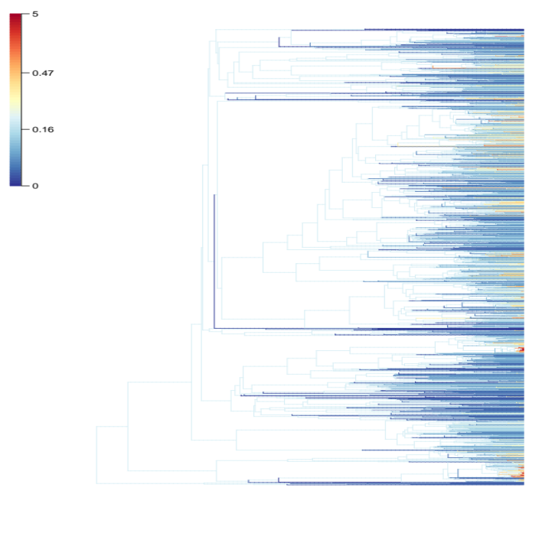
Figure 1: Phylogenetic tree of all 1931 species included in the data with DR values superimposed on top of branches. Cool colors indicate lower DR, and warm colors indicate higher DR. Visual representation of tree used by STRAPP to determine correlation.

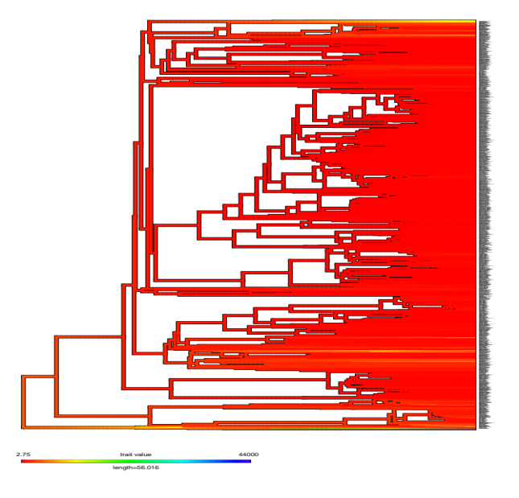
Figure 2: Phylogenetic tree of all 1931 species included in the data showing evolutionary patterns of the Body Mass (BM) trait. Cool colors indicate lower BM, and warm colors indicate higher BM. Visual representation of tree used by STRAPP to determine correlation.
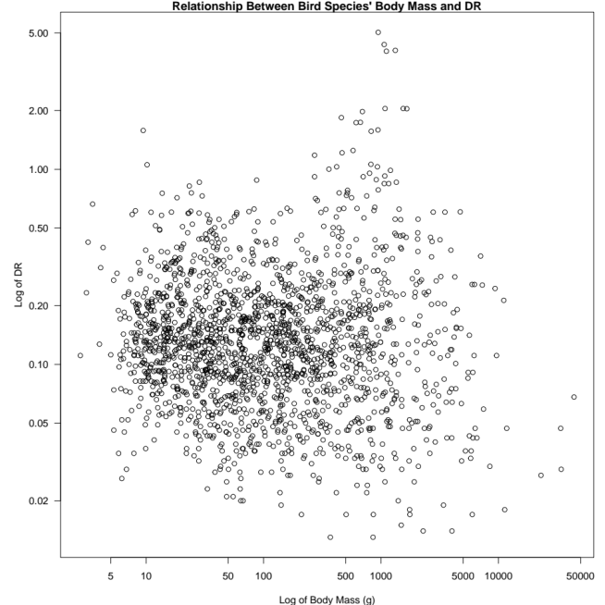
Figure 3: Body Mass values in grams plotted against DR for all 1931 species included in the data. Log of original values were used to make the data easier to visualize. “STRAPPoutput” function correlation value (Spearman method) = -0.05. P value = 0.00.
Figure 1 displays a phylogeny tree of the 1931 birds used in this analysis with DR values corresponding to the different species shown throughout their evolution. There is some variation in DR throughout the phylogeny, especially near the tips where increased speciation is occurring. It is a visual representation of one of two trees the STRAPP model used to determine a correlation. Figure 2 displays a phylogeny tree of the 1931 birds used in this analysis with body mass values corresponding to the different species shown throughout their evolution. To the naked eye, there is minimal variance in body mass values throughout most of the phylogeny. It is a visual representation of the other one of two trees the STRAPP model used to determine a correlation.
Figure 3 displays an x-y scatter plot of the two tested traits: body mass and DR. Log values of the traits were used in this plot to make the data more easily visible. Using the Spearman method of correlation testing, the “STRAPPoutput” function measured the correlation between the two traits to be -0.05, with a p-value of 0.00.
Discussion
The results of the STRAPP analysis state that there was a -0.05 correlation score (Spearman method). This value is close enough to 0 (on a -1.00 to +1.00 scale) to conclude there was no substantial correlation found between body mass and DR for this set of data. This result was supported by a p value of 0, meaning the test was statistically significant and there was an extremely minute chance of the result being due to random sample error. Based on these figures, the original hypothesis that body mass and DR in these birds would be correlated can be rejected. Again, for the purposes of this experiment, DR can be viewed as more representative of speciation rate than anything else, including net diversification rate.
Body mass is just one intrinsic factor of birds. Brain size, another intrinsic factor of birds, has already been linked to DR (Sayol et al. 2019). Intrinsic factors other than those two could exhibit a correlation with DR, if tested. Further research should be done to confirm or deny this, as the results will further our understanding of the factors that influence DR.
It is important to note that these 1931 bird species are not indicative of all bird species on earth. It would still be possible that a sample of other species could exhibit a correlation between body mass and DR. Further testing on different species of birds could either confirm or deny this. Another possible factor in the data that could have influenced the results of this test is the fact that body mass measures were only recorded for one individual per species. This could cause problems if, for example, multiple species measured exhibited abnormally low or high body mass values relative to the typical body mass of that species. This problem could be fixed by sampling the body masses of multiple individuals for each species, and perhaps using the mean or median of those measurements. This could potentially have a significant impact on the results of future tests, and would be worthwhile to do because it likely would yield more accurate results.
Another important factor worth mentioning is that no statistical test is perfect. When conducting tests such as this one, we are confined to using only what current technology allows. As new innovations are created in the future, perhaps methods of testing such relationships will change, leading to more accurate results. For now, however, the STRAPP test is one of the most robust models for testing hypotheses like the one proposed in this paper. There have been concerns expressed regarding the accuracy of the processes BAMM uses to predict likelihoods, rate shifts, and DR (Moore et al. 2016), but it has been shown that in most cases, BAMM is indeed accurate and able to be trusted (Rabosky et al. 2017). Regardless, those concerns likely do not apply to this test since the DR values used were taken from previously gathered data rather than predicted using BAMM.

Acknowledgements
Thank you to my family and friends for supporting me during trying times, and thank you to Dr. Jonathan S. Mitchell for challenging my knowledge and ideas which made me a better student, and writing the code for the STRAPP test and two of the three figures.

Code and Data Availability
RStudio (version 2021.09.1+372) was used to run all tests and create all figures. Code for this analysis can be found at https://github.com/loganb38/Tasks/tree/master/Project. The data used can be found at https://datadryad.org/stash/dataset/doi:10.5061/dryad.p4v4n0s.
Literature Cited
Diaz, L. F. H., L. J. Harmon, M. T. C. Sugawara, E. T. Miller, and M. W. Pennell. 2019. Macroevolutionary diversification rates show time dependency. Proceedings of the National Academy of Sciences 116:7403-7408. https://doi.org/10.1073/pnas.1818058116.
Gillespie, R. G., and G. K. Roderick. 2014. Geology and climate drive diversification. Nature 509:297-298. https://doi.org/10.1038/509297a.
Jenks, G. F. 1967. The data model concept in statistical mapping. International Yearbook of Cartography 7:186-190.
Jetz, W., G. H. Thomas, J. B. Joy, K. Hartmann, and A. O. Mooers. 2012. The global diversity of birds in space and time. Nature 491:444-448. https://doi.org/10.1038/nature11631.
Kembel, S. W., P. D. Cowen, M. R. Helmus, W. K. Cornwell, H. Morlon, D. D. Ackerly, S. P. Blomberg, and C. O. Webb. 2010. Picante: R tools for integrating phylogenies and ecology. Bioinformatics 26:1463-1464. https://doi.org/10.1093/bioinformatics/btq166.
Moore, B. R., S. Höhna, M. R. May, B. Rannala, and J. P. Huelsenbeck. 2016. Critically evaluating the theory and performance of Bayesian analysis of macroevolutionary mixtures. Proceedings of the National Academy of Sciences 113:9569-9574. https://doi.org/10.1073/pnas.1518659113.
Rabosky, D. L., F. Santini, J. Eastman, S. A. Smith, B. Sidlauskas, J. Chang, and M. E. Alfaro. 2013. Rates of speciation and morphological evolution are correlated across the largest vertebrate radiation. Nature Communications 4:1958. https://doi.org/10.1038/ncomms2958.
Rabosky, D. L., M. Grundler, C. Anderson, P. Title, J. J. Shi, J. W. Brown, H. Huang, and J. G. Larson. 2014. BAMMtools: an R package for the analysis of evolutionary dynamics on phylogenetic trees. Methods in Ecology and Evolution 5:701-707. https://doi.org/10.1111/2041-210X.12199.
Rabosky, D. L., and H. Huang. 2016. A robust semi-parametric test for detecting trait-dependent diversification. Systematic Biology 65:181-193. https://doi.org/10.1093/sysbio/syv066.
Rabosky, D. L., J. S. Mitchell, and J. Chang. 2017. Is BAMM flawed? Theoretical and practical concerns in the analysis of multi-rate diversification models. Systematic Biology 66:477-498. https://doi.org/10.1093/sysbio/syx037.
Redding, D. W., and A. O. Mooers. 2006. Incorporating evolutionary measures into conservation prioritization. Conservation Biology 20:1670-1678. https://doi.org/10.1111/j.1523-1739.2006.00555.x.
Revell, L. J. 2011. Phytools: an R package for phylogenetic comparative biology (and other things). Methods in Ecology and Evolution 3:217-223. https://doi.org/10.1111/j.2041-210X.2011.00169.x.
Sayol, F., O. Lapiedra, S. Ducatez, and D. Sol. 2019. Larger brains spur species diversification in birds. Evolution 73:2085-2093. https://doi.org/10.1111/evo.13811.
Sayol, F., O. Lapiedra, S. Ducatez, and D. Sol. 2019. Data from: Larger brains spur species diversification in birds. Dryad Digital Repository. https://doi.org/10.5061/dryad.p4v4n0s.
Title, P. O., and D. L. Rabosky. 2018. Tip rates, phylogenies, and diversification: What are we estimating, and how good are the estimates?. Methods in Ecology and Evolution 10:821-834. https://doi.org/10.1111/2041-210X.13153.

